Washington State Obedience Training Club

is proud to present World-Renowned Canine Expert, Teacher and Trainer

Diane Bauman
- The Gap Between Training and
Trial Performances
- Training the Thinking Dog
- Heeling as Dancing Partners

June 12-13, 2021
Country Classic Canines
9332 99th Ave NE, Arlington, WA 98223

Come and spend a weekend with one of the founders of modern dog training. Her book “Beyond Basic Dog Training,” first published in 1986 and now in its Third revision, helped to revolutionize our sport. Her success, especially with non-traditional breeds is renowned and unparalleled. Diane is one of the most innovative and out-of-the-box trainers and competitors of our time.
DianeBauman.com

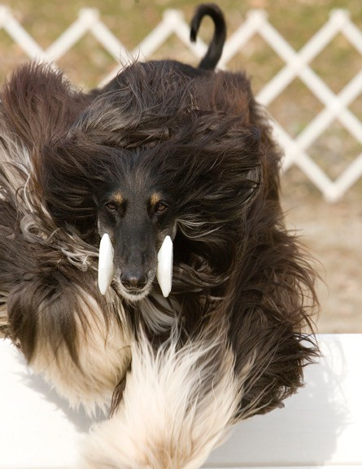
Diane is also a recognized expert and competitor in agility with World Team experience. Since “dog training is dog training”, agility competitors should also benefit from this seminar. For further details on the topics to be covered and the details of the seminar, contact Nancy Light
There are NOT working vs. auditing spots.
All participants may bring a dog if desired. Seminar format is lecture, demonstration, and some audience participation. There will be opportunities to work with dogs on problem solving and mastering new skills.
WSOTC members: 1 day $115 2 days $200
Non-WSOTC members: 1 day $125 2 days $225

Registration is limited to about 50 each day based on order of receipt of registration. Questionnaire will be sent to participants prior to the seminar.

Contact: Nancy Light kylahgold@aol.com 425-354-3609

Dog friendly Hotels: Quality Inn Arlington WA 360-474-4625;

Smokey Point Motor Inn, Arlington WA 360-658 1330

The above may offer discount for those specifying WSOTC

RV Parking: Lake Goodwin Resort (360) 652-8169 Lake Connor RV Park (425) 334-5044

Registration Form for Diane Bauman Seminar June 12-13, 2021

Name

Address: ______________________________________________________

City_____________________________________State_______Zip___________

Email Address (Print clearly) ____________________________________Phone ____________________
Are you interested in working a dog ___________Yes ___________No _________Maybe

Check which days you want to attend:
Saturday June 12, 2021
Sunday June 13, 2021
WSOTC member? ______________yes ________________No
WSOTC members: 1 day $115 2 days $200
Non-WSOTC members: 1 day $125 2 days $225
$ total enclosed
No refunds after May 3, 2021
Make checks payable to WSOTC
Mailing address: Rhonda Forman PO Box 849 Carnation, WA 98014

You will receive an email confirmation of your registration soon after receipt and a questionnaire and more details on the seminar closer to the seminar date

I understand that attendance at a dog training facility is not without risk to myself or my dog(s). I hereby waive and release WSOTC and Country Classic Canines from all liability of any nature resulting from the actions of any dog while on the grounds of Country Classic Canines during the Diane Bauman workshop on October 24-25, 2020

Signature _________________________________________________Date ______________

Registration Questions contact Rhonda Forman rdlahey@hotmail.com 206-930-5134

Questions on content and other questions on the seminar contact Nancy Light: kylahgold@aol.com 425-354-3609

